
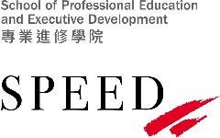
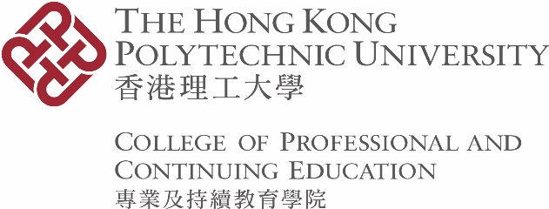

Form CAR 14

Application for Deferment of Study

Please read the notes overleaf before completing this form.

PARTICULARS OF STUDENT
Student No.
Name
Programme Code Stream Code
Programme Title |  |  |  |  |  |  |  |  |  |  |  | -
Contact No. |  |  | Mode of Study |  | ◻ Full-time ◻ Part-time
Are you a non-local student requiring visa/ permit to stay in Hong Kong? |  |  |  |  |  | ◻ Yes ◻ No
Is this the first year (two semesters) of study for the programme indicated above? |  |  |  |  |  | ◻ Yes ◻ No

- APPLICATION DETAILS

- I wish to defer my programme of study with effect from Semester One/ Semester Two/ Summer Term * of the Academic Year 20 / for ____ semester(s) and to resume study in Semester One/ Semester Two/ Summer Term * of the Academic Year 20 / . I understand that I should remain in class until I receive written approval from the CPCE Academic Registry.

- Reason(s) for application #

# Supporting document(s) should be accompanied with this application.

- I have/ have not * been advised to have late assessment in the current academic year.

Signature of Student |  | Date | Click or tap to enter a date.

FOR ACADEMIC STAFF AND OFFICE USE ONLY

◻ This application is supported/ rejected * by (Assistant) Programme Leader

Signature _______________________________________ Date ___________________________
(Name: )

◻ This application is approved/ rejected * by Head of Programme Administrative Hosting Division concerned or his/ her delegate (for supported case only)

Signature _______________________________________ Date ___________________________
(Name & Position: )
◻ Notification sent to student by ______________ on ________________
◻ (For approved case) Computer record updated by ___________________ on ___________________
◻ (For approved case) For non-local student, notification sent to the HKSAR Immigration Department within seven days by ______________ on ________________

* delete as appropriate
Notes TO students

- Applications for deferment of study should be submitted by the following timelines:
  - Applications for the current semester/ term: before the commencement of the examination period of the semester/ term concerned. Applications submitted after the commencement of the examination period will not be processed.
  - Applications for the following academic year/ semester/ term: before the commencement of that academic year/ semester/ term. Applications will only be considered after the announcement of assessment results of the current semester/ term.
- Applications for deferment of study in the following situations will only be considered under exceptional circumstances:
- Students in their first year (two semesters) of study
- Periods of more than one year (two semesters)
- For non-local students who are approved for deferment of study, the CPCE Academic Registry will inform the HKSAR Immigration Department accordingly. Upon resuming studies at the end of the approved deferment period, you must hold a valid student visa/ entry permit. Please refer to the notes stipulated in the section “Important Notes for Students Holding Visa / Entry Permit to study in Hong Kong” in the Student Handbook.
- The deferment period will not be counted towards the total period of registration (or maximum period of registration for students admitted in or before 2019/20) of the students concerned. Students are generally not eligible to use the campus facilities/ services during deferment.
- Instead of deferment of study, you may consider applying for retention of study place (zero subject enrolment) by completing Form CAR 24. The semester(s) during which students are allowed to retain their study places will be counted towards the total period of registration (or maximum period of registration for students admitted in or before 2019/20) of the students concerned. If the application for retention of study place (zero subject enrolment) is approved, a fee will be charged. Students will be allowed to continue using campus facilities/ services.
- Students who have a genuine need and wish to apply for deferment of study should obtain prior approval from the Head of Programme Administrative Hosting Division concerned. Please follow the application procedures specified below:
- Complete Sections I and II of this form;
- Submit the completed form with documentary proof, such as medical certificates, to the CPCE Academic Registry. Applications without valid documentary proof will not be processed.
- CPCE reserves the right to request the original copy of the documentary proof, where necessary, and verify the supporting documents submitted by students. If it is found that false document has been provided, the students concerned may be subject to disciplinary action(s).
- It is necessary for students to settle the outstanding tuition fee and/ or other fees, if applicable, in order to have their applications processed if such applications are submitted after the start of a semester. All fees paid are non-refundable and non-transferable. However, for current students who submit applications before the commencement of the relevant semester, tuition fees paid will be refunded.
- New students who submit applications before the commencement of the programmes and are approved for deferment of study for their first semester of study under exceptional circumstances will be eligible for a refund of the tuition fee paid for that semester after deducting the registration fee. If the tuition fee paid is equal to or less than the amount of the registration fee, no refund will be arranged.
- You will normally receive written notification of the application result within three weeks from the date of your application or one week before the deferment of study takes effect, whichever is later. You must remain in class until you receive written approval.
- Students are reminded to regularly access the my.HKCC/ my.SPEED Student Portal and check their emails to obtain up-to-date information relating to their studies during the deferment period.
- Upon the expiry of the deferment period, you will be advised to settle the tuition fees and complete the subject registration procedures for the semester in which your study will resume. If you do not receive such notification one week before the commencement of the academic year/ semester, please contact the CPCE Academic Registry. You should retain the Student ID Card for use upon resumption of study, or for exchange of a new Student ID Card if it has expired.
- The current level of tuition fees is applicable to studies within the normal duration of your programme, as specified in the Scheme/ Programme Requirement Document. Should you have to extend your study beyond the normal duration of your programme, the adjusted tuition fees, if any, will apply.
- The information given in this form will only be used for processing this application and/ or statistical purposes.

Submission Method: | Email: | cpce.ar@cpce-polyu.edu.hk

