
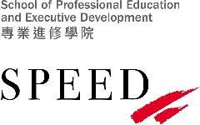
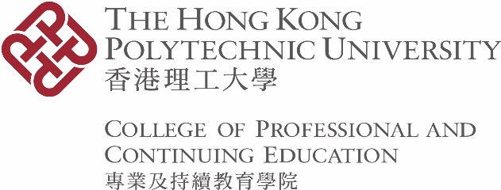

Form CAR 19
Application for Certification of Award

Please read the notes overleaf before completing this form.

- PARTICULARS OF APPLICANT
Student No.
Name
HKID Card/ Passport/  PRC Resident ID Card No. * |  |  | Contact No.
Email Address

- AWARD DETAILS
No. | Title of Award(s) Obtained | Programme Code | Year of Graduation  (e.g. 2024/25)
1
2

- DECLARATION
I am aware that I am not permitted to retain more than one copy of the award certificate for each academic qualification, including the Certification of Award obtained from Hong Kong Community College (HKCC)/ School of Professional Education and Executive Development (SPEED) * of The Hong Kong Polytechnic University. I hereby declare that my original award certificate(s) for the academic qualification(s) stated in Part II of this form is/ are lost.

Signature of Applicant |  | Date | Click or tap to enter a date.

- FOR OFFICE USE ONLY
◻ Collection status in Student Management System checked by ______________ on ___________________
◻ HKID Card/ Passport/ PRC Resident ID Card * checked by ________________ on __________________
◻ Fee of HK$250 per certificate settled on __________________
◻ Applicant notified by phone/ email * by ______________ on ___________________

- ACKNOWLEDGEMENT (to be completed by applicant or authorised person upon collection in person)

I acknowledge the receipt of the Certification of Award(s).

Signature of Applicant/ Authorised Person * |  | Date

* delete as appropriate

Notes TO APPLICANTS

- Certification of Award is in general issued to graduates who have lost their original award parchment. It serves as a document certifying the attained award(s) in CPCE but is not an exact copy of the lost award parchment.

- The application procedures are as follows:

- Complete Sections I, II, III and IV of this form.
- Submit the completed form to the CPCE Academic Registry.
- Present your HKID Card/ Passport/ PRC Resident ID Card (for non-local students) for verification upon request.
- Settle a fee of HK$250 for EACH Certification of Award for the 2026/27 academic year, which is subject to annual review. Payment can be made by Octopus, through PolyU Online Payment Portal (POPP) or using the debit note obtainable from the CPCE Academic Registry. Fees paid are non-refundable and non-transferable.

- If you authorise another person to collect the Certificate(s) of Award on your behalf, please provide a letter of authorisation along with this application form. The letter should state the name and the number of HKID Card/ Passport/ PRC Resident ID Card of the authorised person. A copy of your HKID Card/ Passport/ PRC Resident ID Card, the authorised person’s HKID Card/ Passport/ PRC Resident ID Card, and the original authorisation letter will be required for verification upon collection of the certification(s) of Award. A copy of the identification documents will be returned to the authorised person afterwards.

- The processing time for issuing a Certification of Award is normally seven working days from the date of receiving the application.

- If the Certification of Award is not collected within three months from the date of notification, it will be destroyed for security reasons.

- The information given in this form will only be used for processing this application and/ or statistical purposes.

Submission Method: | Email: | cpce.ar@cpce-polyu.edu.hk

